**SQL ASSESSMENT**

1. Create a table Student (ID int, Address varchar) and apply check constraint on a column in which it allows only the alphabets in the column.
2. Find Second Most Recent Order Date

Write a SQL query to find the second most recent order date for each customer from a table Orders (OrderId, CustomerID, OrderDate)

1. Find highest salary

Write a query to find the highest salary from a table Employees with columns EmployeeID, Name and Salary

1. Create a table. Find total number of matches played by each team.

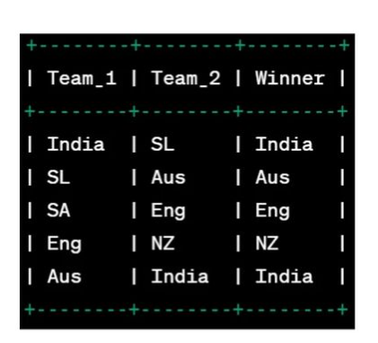

1. Create tables Product and Sales

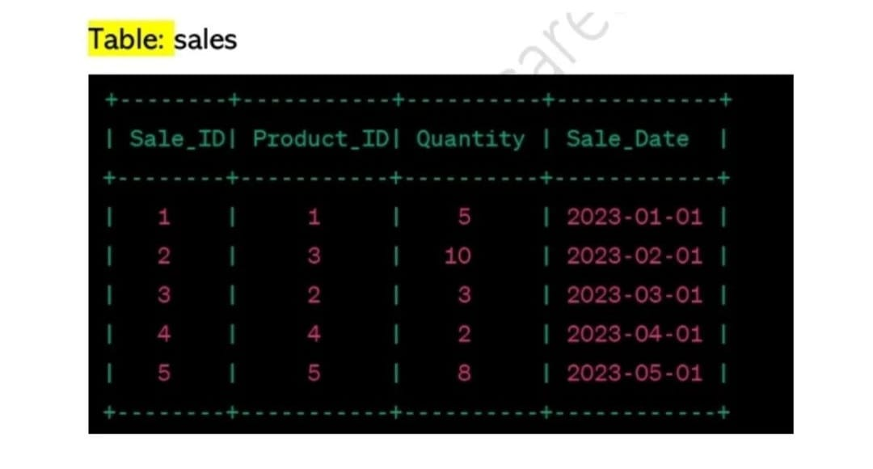

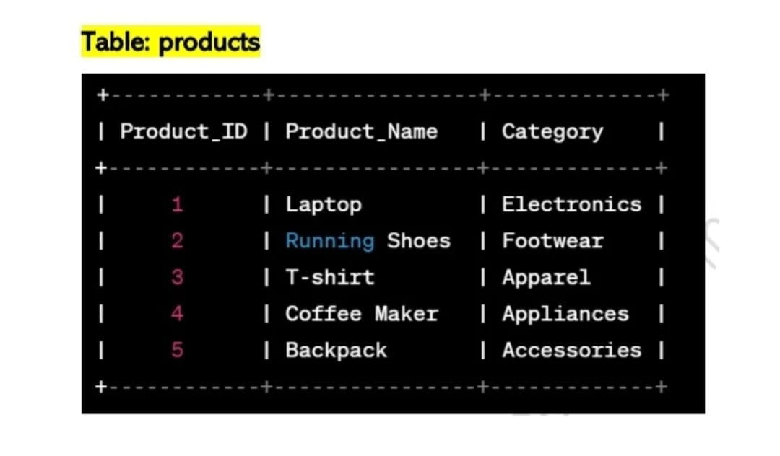

Find the total quantity of each product sold